Virginia Library Association
VLA Council
Virtual Zoom Meeting
Friday, April 3, 2020

Attendees:
Executive Committee – Joslyn Bowling-Dixon, Regina Carter, Bill Edwards-Bodmer, Kayla Payne, Jennifer Resor-Whicker, Jessica Scalph, Lisa Varga, Lucinda Rush Wittkower
VLA Council – Phil Abraham, Alisha Barnes, Cindy Church, Kerri Copus, Easter DiGangi, Christina Harris, Minerva Hernandez, Shaunna Hunter, Kristi Jerome, Jessee Kelley, Cammy Koch, Paula Kiser, Rebecca Lamb, Kate Lynch, Ginny Pannabecker, Anne Rappe-Epperson, Sophie Rondeau, Tom Shepley, April Watkins, Adrian Whicker

Call to Order & Introductions
Jennifer Resor-Whicker called the meeting to order at 10:04 am. Attendees are asked to type their name and where they work into the chat box rather than going around and introducing themselves. Jennifer read the working remote COVID-19 principles:
- You are not working from home; you are at home during a crisis trying to work.
- Your personal, physical, mental and emotional health is far more important than anything else right now.
- You should not try to compensate for lost productivity by working longer hours.
- You will be kind to yourself and not judge how you are coping based on how you see others coping.
- You will be kind to others and not judge how they are coping based on how you are coping.
- Your team’s success will not be judged the same way it was when things were normal.

Secretary’s Report
Kayla Payne emailed the minutes of the Council meeting held in January prior to this meeting. The January minutes can be seen here: https://www.vla.org/assets/VLACouncilJan20.docx

Kristi Jerome moved the minutes be approved. Paula Kiser seconded, and the motion carried.

Yesterday the Executive Committee discussed our ability to meet and vote in this manner. According to our bylaws, we can conduct business by mail, email, fax, or teleconference. We are interpreting this meeting as a telephone call. Once we can meet in person, we should consider revising our bylaws or adding the ability to meet by video conference.

Treasurer’s Report
Bill Edwards-Bodmer gave the treasurer’s report. The report can be viewed here:
https://www.vla.org/assets/2020%20BUDGET%20WITH%20INVESTMENTS.pdf

Executive Director's Report
Lisa gave the Executive Director’s Report. The report can be viewed here: https://www.vla.org/assets/Executive%20Directors%20Report%20April%202020.pdf

2020 Membership
- 279 Individual Members
- 71 paid Affiliate Members (4210 employees)/4 not yet renewed (34 employees/$1950 in lost revenue)
- 41 Life Members
- Institutional Invoices sent (current income $33,997 out of an expected $45,720)

Joblines:
37 postings
8 Complimentary for Institutional Memberships
$2,225 revenue
7 currently unpaid

VLA Annual Conference: Change to location and dates
Marriott Norfolk Waterside, October 21-23, 2020. Lisa explained why the conference was relocated and the factors that go into selecting conference locations.

Updates from January 2020 Executive Director Report

Macmillan eBooks
Macmillan has ended its embargo as of March 17. Many libraries have boycotted Macmillan. VLA, as an association, cannot and will not endorse a boycott. For more information, please research the Sherman Antitrust Act. VLA is supporting ALA’s #ebooksforall campaign.

Conference Discounts Restructure beginning with 2020
All VLA Council Chairs, members of the VLA Executive Committee and the members of the Conference Committee will receive a discount code for $75 off their conference fees for the year(s) in which they are serving the Association. All presenters will also receive a discount of $75 (up to two presenters per session, up to two presenters per poster, and up to two presenters per lighting talk.)

National Library Legislative Day, 2020: CANCELLED
VLA was anticipating spending approximately $6000 on this event for VLA President, President-Elect, VLA’s ALA Councilor and VLA Executive Director to attend, as well as reimbursements for VLA members.

My planned conferences for 2020 are:
- ALA Midwinter (presenting at the Chapter Leaders Forum)
- PLA in Nashville
- VPLDA Annual in April CANCELLED
- National Library Legislative Day in DC CANCELLED
- ALA Annual in Chicago (presenting at the Chapter Leaders Forum) CANCELLED
- All 6 regional workshops for VLAPAF, currently in planning stages CANCELLING APRIL-JUNE DATES

Executive Committee
Jennifer gave the Executive Committee Report. The Executive Committee met yesterday and discussed changes to the Virginia Libraries Journal editorial board in light of Cori Biddle stepping down as Managing Editor. Ginny Pannabecker will be addressing more about that in her unit report.

Changes have been made in the manual to the Honorary Life Membership as voted upon in January. The Committee also discussed the potential of making June another virtual meeting. Since things are still up in the air, we will revisit that in the coming weeks.

VLA Annual Conference
The new conference dates will work for Beth Macy, our keynote speaker. There are more dining options at the Norfolk than there would be at the Homestead. The plan is to start Wednesday afternoon of conference with a wine and cheese poster session that will lead into a costume party. Scholarship and Awards banquet will be held Thursday evening with the 90s party/social to follow. Friday will start with sessions and end closer to lunch with the business meeting and scholarship raffle.

We are moving ahead with the idea that our conference will happen in October and considering alternate virtual options to offer equitable access. Session proposals are due April 15 right now, but we may consider extending the deadline.

Unit Reports
ALA Councilor (report submitted by Lucinda Rush Wittkower)
Lucinda Rush Wittkower gave the chapter councilor’s report. It can be viewed here: https://www.vla.org/assets/ALA%202020%20Midwinter%20Report.docx

Documents

- All 2020 Council Documents
- Complete list of ALA Council Actions

Highlights
- ALA Budget
ALA’s budget dominated ALA Council Session III and Council Forums II and III. This summary describes the state of ALA’s budget: ALA Responds to Financial Shortfall

- Tributes Adopted
Florida Library Association’s 100th Anniversary
Dita Kraus, “The Librarian of Auschwitz”

- Resolutions Adopted

Resolution ensuring intellectual freedom and the right to peacefully assembly at ALA Conferences and Meetings
This resolution was primarily in response to ALA’s creation of “The Square,” which was later revoked. The resolution requires that ALA Council approve all internal restrictions to First Amendment rights at all ALA events proposed by all ALA offices, ALA committees, or other ALA bodies.

Resolution in opposition to charging prisoners to read
This resolution was a statement that condemns the existence of for-profit programs that charge incarcerated people for access to reading material, acknowledging such programs deepen existing inequalities barring free access to information for all people. ALA strongly encourages library workers to contact state legislatures to express this concern.

- Steering Committee on Organizational Effectiveness Updates (SCOE)
The document, Forward Together, proposes a new governance model for ALA, which was developed by the SCOE committee. The next steps are for a legal analysis of the proposal to be conducted and presented. SCOE also recommends a more robust financial analysis. The timeline beginning on page 30 of the Forward Together document (linked above) provides more details for next steps. ALA Council was to hold vote 1 at ALA Annual 2020 which has now been canceled.

Meetings Attended by VLA Chapter Councilor

Saturday, January 25
ALA Council Orientation Session for New and Re-elected Councilors, 8:00-10:00 AM
ALA Council/Executive Board/Membership Information Session, 3:30-5:30 PM
ALA Council Forum I, 6:00-7:00 PM

Sunday, January 26
ALA Council I, 9:00 AM-11:00 AM
Steering Committee on Organizational Effectiveness: Forward Together & Chapters Discussion, 4:00-5:00 PM
ALA Council Forum II, 5:30-6:30 PM

Monday, January 27
ALA Council II, 10:00 AM-12:00 PM
Chapter Relations Committee 2, 1:00 PM-2:30 PM
ALA Council Forum III, 5:30-6:30 PM

Tuesday, January 28
ALA Council III, 8:30-11:00 AM

Association of College Research Libraries (VLACRL) (report submitted by Sophie Rondeau)
Officers
Chair: Sophie Rondeau, VIVA, Term ends: 2021; Co-Chair: Candice Benjes-Small, William & Mary, Term ends: 2022; Lisa Nickel, William & Mary, Term ends: 2020; Secretary/Treasurer: Kate Lynch, Hampden-Sydney College, Term ends: 2021.

Updates
The VLACRL Spring Program, which was being planned for April 24 at Stafford Campus, University of Mary Washington, Fredericksburg, has been rescheduled to August 5, 2020 at VCCS, Richmond, VA. A save-the-date announcement has been posted to Facebook but registration won’t open until we have a better sense of the circumstances surrounding the COVID-19 pandemic. VLACRL is not planning a summer program given the schedule change to the spring program.

Kate Lynch, Secretary/Treasurer prepared two posters for the program:

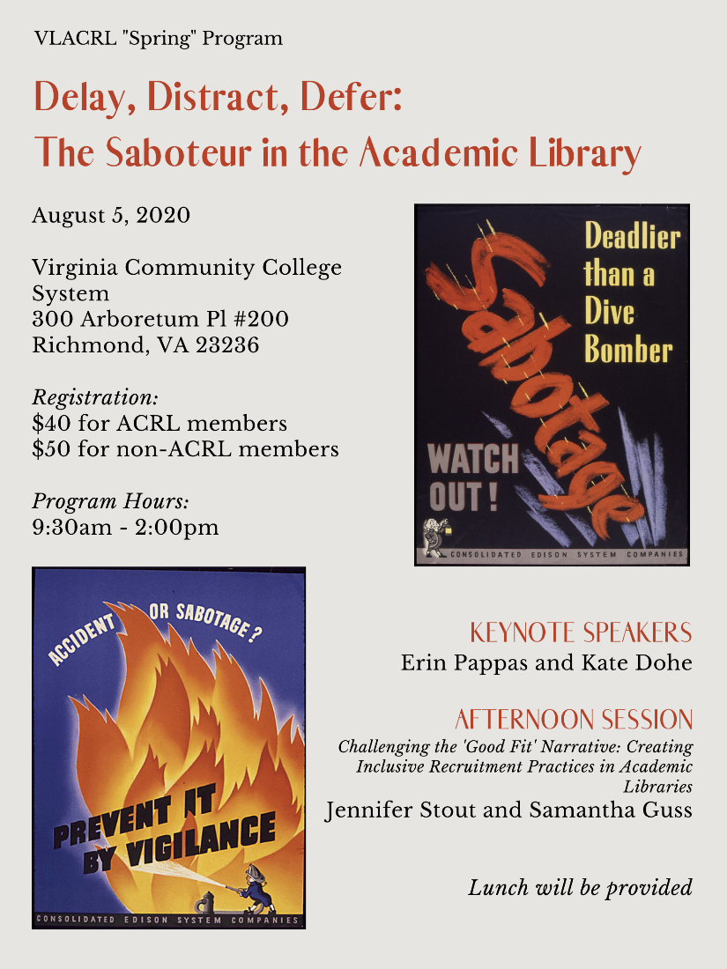

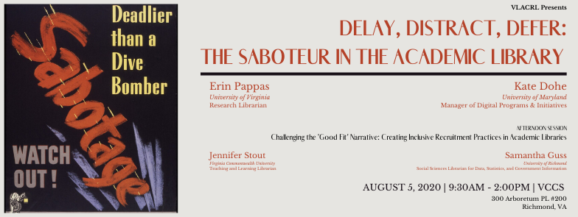

Jennifer Resor-Whicker added that The Innovative Library Classroom (TILC) has been postponed until June 2021.

Awards and Recognition Committee
Shaunna Hunter reported. Awards nominations are open and will be extended through the end of May. You can find the links and descriptions on the VLA website.

Collection and Technical Services Forum (CaTS) (report submitted by Easter DiGangi)
CaTS Executive Board
We have expanded the CaTS Executive Board from two officers (Chair and Co-Chair) to seven
so that we can provide more leadership opportunities and to provide more to the CaTS
membership in general. At this time, we have recruited three additional people (Jessica
Robertson, Immediate past chair; Kyle Binaxas, Secretary; and Mary Ann Hayden,
Communications & Outreach Director) leaving 2 vacancies (Conference Director and
Programming Director). We are working to put together a plan and structure to have a forum
election for leadership.

Professional Associates collaboration
On March 4th, we gave the first of two collection-related presentations as part of our
collaboration with the Professional Associates Forum during their Regional Workshop Tour.
CaTS Forum member Virginia Phelps presented a training on Weeding Basics to approximately
25 members of the Professional Associates Forum at Longwood University in Farmville. The
audience appeared engaged, participated in the dialog portions, and asked relevant questions.
Our next presentation is scheduled for the Region 4 portion of the Professional Associates
Regional Workshop Tour in August.

Technical Services Regional Learning Workshops
Due to concerns of the Coronavirus, we postponed our three March workshops in Regions 4, 1,
and 5. We hope to reschedule in person if possible, but if not we will work to come up with
virtual events instead. Given the Governor’s Stay at Home Order, it is probable that we will have
to also postpone the Region 2 (5/12) and Region 6 (5/28) events. In the meantime, we are
working to engage CaTS members not only with our e-list but also with regional e-circles that we developed on VLA.org. We have been thinking of other e-circle usages as well that would help serve membership needs (e.g. managers, topic specific).

VLA Conference
We plan on having a forum where we are broken out into topical roundtables (which people
self-select for). At the end, a representative from each roundtable will share with the whole
group so that folks will learn not only from the roundtable that they chose to participate in but
also from the other topics.

We are trying to encourage other CaTS members to submit proposals for VLA as well. One
thing we want to work toward is a Conference Proposal matching service where folks interested
in being a panelist can be brought together to present a session.

Continuing Education Committee (report submitted by Alisha Barnes)
Heather Simpson from Chesapeake Public Library is the new co-chair of the Continuing Education Committee. We’re working on a review of the Career Resources page of the association’s website and other state library association’s continuing education committees. We are still looking to recruit new members to the committee.

VALLA (Virginia Library Leadership Academy) has been postponed until September 16-17.

Intellectual Freedom Committee (report submitted by Rebecca Lamb)
I missed the last Council meeting, so am catching up with this report.
We selected the following winners of our annual Banned Books Week contest:
- Best Public Library Display: Dr. Clarence V. Cuffee Branch, Chesapeake Public Library in Chesapeake, VA
- Best Academic Library display: Glenns Campus Library, Rappahannock Community College, Saluda, VA
- Best School Library: Corporate Landing Middle School, Virginia Beach, VA
Brian Manning, Regional Library Director of the Appomattox Regional Library System, is now the IFC’s Vice-Chair. We have accepted two new members: Amanda Jackson, Director of Libraries with the Chesapeake Public Library, and Ana Corral, Resident Librarian with Virginia Tech University Libraries. This brings our membership up to the full ten members, with all regions represented.
We had members ready to attend, but the Freedom on Information Day wreath-laying ceremony at James Madison’s Montpelier was canceled this year. However, we are working on a program proposal for the VLA Conference and should have that submitted shortly.
We continue to update the IFC webpage with intellectual freedom news from around the state and are working with Lisa Varga and the Website Content Committee to give state intellectual freedom news a presence on the landing page of the VLA website.
Jefferson Cup Committee (report submitted by Katie Heslop)
Kayla Payne read the report. Our final meeting for Jefferson Cup was supposed to be April 17th but has been postponed due to the extenuating circumstances for our members. Our final meeting will now be held mid-May (TBD), and will most likely be virtual.

Legislative Committee
Phil Abraham gave the legislative update. Phil thanked Tom for his work as chair of the Legislative Committee. The General Assembly adjourned five days late this year from its “long session”, ending on March 12 instead of March 7. This pushed the governors bill review process to April 11 at midnight.

In terms of legislation, the committee worked on four issues:

- House Bill 313 and Senate Bill 259 dealt with the FOIA exemption for library records and public access. It amended the current restriction on records to your patron’s information to account for electronic records. Previously it referred to borrowed materials and now includes electronic resources. This bill was put in at the request of Loudoun County by Wendy W. Gooditis and John Bell.
- House Bill 404 came out of Fairfax County and declares public libraries are an essential service per the state code. Previously, it was defeated because people were wondering about the budget implications of such language. Governor Northam has yet to sign this bill into law.
- A bill Phil expected to pass but was defeated was for public law libraries, giving localities the option to increase the fee that is put on court costs to fund local public law libraries. The bill sailed through the House, made it out of the Senate Committee and died on the floor of the Senate by a 19-21 vote. Arguments against the bill were in response to fee increases that defendants have to pay.
- One issue that comes up issue year after year is to allow localities to prohibit firearms in public libraries. This year the House and Senate passed 6 or 7 major pieces of gun reform legislation. Senate Bill 425 and House Bill 421 allows localities what public buildings guns may or may not be allowed in. Until your locality says otherwise, the current law stands.

Senator Tommy Norment from James City County, Mark Sickles from Fairfax County and Creigh Deeds from Bath County put in our budget amendment which requested the first two years of a four year phase in of full funding of state aid to local public libraries. It would have been a little over $2.5/2.75 million increase per year. All new chairs of the Finance and Appropriations subcommittees include: Mamie Locke from Hampton, Betsy Carr from Richmond, Jeanette Hough from Fairfax, and Luke Torian from Prince William County. The Senate recommended a 1.5 million dollar increase for each year of the biennium. The House gave a million dollar increase for State Aid. This would be our 3rd biggest increase in history.

The Governor will propose his budget on or after April 12. All new money in the budget may be swept into a reserve account due to COVID. The veto session will be held April 22. We will be watching for a special session during the summer or fall. The General Assembly has no plans for virtual meetings.

LGBTQIA+ Forum
Christina Harris reported. Announcement went out on the listserv, with 8 responses to join so far. The forum is looking for leadership.

Librarians of Color Forum (report submitted by Joslyn Bowling Dixon)
Pleased to report Regional Coordinators held their first ever meetings. Regions 3 and 5 met in February at the Montclair Branch of Prince William Public Library System and the Pearl Bailey Branch of Newport News Public Library, on February 21 and February 25, respectively. VLA LOC also held its first social function of the year, a brunch at the Salamander Resort and Spa on February 23.

All but two (Region I and II) positions have been filled of available open coordinator/chairperson roles. The VLA LOC Award Committee created a draft for a potential annual award. Will forward draft to Lisa Varga for consideration and coordination with VLA Award Committee.

A VLA LOC representative has also been identified to serve on the Diverse Graphic Novel Award Committee: Myisha Fuller, Head of Teen Services, Rust Branch/Loudoun County Public Library.

The next VLA LOC region meetings will be in May. Will meet with Regional Coordinators in April to virtually to plan for Zoom/WebEx meetings to replace in-person meetings planned for May.

Library of VA
Cindy Church reported. Staff are working remotely to assist patrons online while the building is closed indefinitely. The blog Uncommonwealth blog has ideas of things to do during quarantine that we can share with our patrons at https://uncommonwealth.virginiamemory.com/ . May 1 professional associates meeting “The Day in the Life…” has been postponed and it will be rescheduled. The Southeast Collaborative Online Conference had over 900 attendees. Cindy is working to get continuing education opportunities up on the LDND website.

Local and Family History Forum
No report.

New Members Roundtable (report submitted by Anne Rappe-Epperson)
2020 members of the NMRT include:
- Anne Rappe-Epperson: Chair
- Minerva A. Hernandez Garcia: Vice Chair/Chair Elect
- John Hood-member: Mentoring Co-coordinator
- Irene Girgente: Conference Assistance
- John Connolly: Mentoring Co-coordinator
- Amanda Henderson: Secretary

During the February meeting, the team discussed the possibility of creating a webinar style series that would feature different library professionals. This would be a short webinar highlighting what they do, their title, how they got to where they are, and interesting tidbits of their daily work life. Some presenters suggested included: the NASA Langley Research Center librarian, librarians working archives and genealogy, and librarians that work specifically with children and young adults. Conversation about how the NMRT will participate in the upcoming conference included assigning trivia planning to Minerva Hernandez-Garcia and talk about the NMRT meet and greet party.

The Mentoring Program has opened for applications from both mentors and mentees. This program will allow new VLA members to flourish professionally under the guidance of more tenured VLA members. Though this program is not intended for job searching, it will provide invaluable knowledge and relationships that will be useful for both parties involved. Currently applications close on April 1st, 2020.

Nominating Committee
Jessica Scalph reported. There is a full slate of nominees.

VP/Pres Elect
Nathan Hall – Virginia Tech University Libraries
KT Vaughan – Washington & Lee Library

Secretary
Maryska Connolly Brown – Bortz Library at Hampden-Sydney College
Natisha Harper – University of Richmond?

Professional Associates Forum (VLAPAF) (report submitted by Kristi Jerome)
Bylaws
We have updated our bylaws and committees. The new bylaws have been sent to Lisa Varga for review and to be sent to Council for approval in June. They can be viewed here: https://www.vla.org/assets/VLA%20Professional%20Associates%20Forum%20Bylaws.docx

Regional Workshops
We scheduled all six of our Regional Workshops and was able to hold one before having to postpone them due to COVID 19. The workshop at Longwood University was a success with just over 20 attendees. The workshop ran from 10 AM to 3 PM. We are collaborating with CaTS by having Virginia Phelps come and speak about weeding and collection management. We also had two speakers, Leticia Zelaya and Dianne Walker, from Prince William County Public Library System come and speak about setting S.M.A.R.T. Goals.
What was really encouraging was the amount of networking and advice that everyone was able to give each other. We were able to stimulate productive conversation through our round-table topic questions. We have not had any additional requests to join VLA PAF yet, but that is understandable due to global circumstances.

VLAPAF Conference 2021
We have the Marriott hotel in Newport News reserved for April 25-27, 2021.

Programming Forum (report submitted by Jesse Kelly)
The Programming Forum Circle members held an election for the Vice Chair position. Jennifer S. Brown from Suffolk Public Library was elected as Vice Chair. The Circle currently has 26 members. I would like to thank Regina Carter for helping us get the Forum's page in order. I would also like to ask if Circle members need to ask for notifications once discussions have been posted to their Circles. We have about 8 discussions but very few replies. I'm not sure people are getting updates on discussions in a timely manner. This is all I have to report at this time.

Scholarship Committee (report submitted by Kerri Copus)
The 2020 VLA Scholarship applications closed on March 6 with a total of 23 applicants. Due to the various library closures we extended the rankings deadline to Sunday, April 5th. Several committee members have sent in their scores already. The committee plans to announce the winners by mid-April. We are awarding 3 scholarships at $3,500

Virginia Association of Law Libraries (VALL)
No report.

Virginia Libraries Journal (report submitted by Ginny Pannabecker)
Current Editorial Board
Julia Feerrar - current term: 2018-2021, Barbara Ferrara - current term: 2018-2021, Sue LaParo - current term: 2017-2020, Virginia (Ginny) Pannabecker (Editor in Chief): 2018-2021, Sophie Rondeau - current term:2018-2021, Lynda Wright - current term: 2018-2021

Editorial Board Updates:
- Update on changes to Editorial Board for Managing Editor, Assistant Editor

Current Journal Status:
- One new Case Study article submission is in review stage
- Two Research articles are nearing proofing stage for v.64 - goal to publish these in April / May 2020
- Project to review journal content in back issues to identify and fix format issues from platform change
  - All content has been reviewed
  - Several cross-platform issues and issues specific to a few articles have been identified, which the editors will address via a meeting with the publishing platform representative and VT support
Outreach
- Planned for Spring/Summer:
  - Update the VLA web page
  - Call for new submissions via our new journal platform
  - Peer Review call and training
  - Author Information Webinars: Introduction to journal, submission, review, and publication process
- Indexing - Investigating additional indexing options (ERIC - Education research database)
- Twitter account - with new journal platform we will build out our social media presence

VLA Liaison to VAASL Board of Directors (report submitted by Kelly Miller)
Kayla Payne read the report.

Annual Conference

The Annual Conference “Branching Out” will be held November 5-7, 2020, at the Westfields Marriott, Chantilly, VA.
- Thursday Keynote: Jaime Donnally
- Friday Keynote: Cicely Lewis
- Friday Awards Banquet with Author Keynote: Dhonielle Clayton
- Saturday Breakfast with Author & Illustrator Panel: Laura Murray, Mike Lowery, Adam Gidwitz, Hatem Aly

Concurrent Sessions Proposal Link: https://docs.google.com/forms/d/e/1FAIpQLSf1aRknytcvrTNUjNX70n2cY8LZdGc-8pbLuSX1q9T_qh4D6w/viewform

Idea Lab Proposals: https://docs.google.com/forms/d/e/1FAIpQLSdDC07qmO0GJCibpZ07iCFDiLPDPk0XkudYjzJLfykuOxFC_A/viewform

School Library Month
April is School Library Month. AASL website has some resources: http://www.ala.org/aasl/advocacy/slm
Governor Northam’s Proclamation: https://www.governor.virginia.gov/newsroom/proclamations/proclamation/school-library-month.html

Committees
Legislative
We appreciate VLA’s support of support t for HB 1415 (clerical staff) and HB 1599 (Library staffing). Although HB 1415 failed, HB1599 was held over for next year. We will develop a plan to support the bill for next year’s legislative session.
The next VAASL Board Meeting is April 25,2020
Website Content Committee (report submitted by Paula Kiser)
The VLA WCC met on February 21st. We went over liaison duties again. Amy White volunteered to take over People & Happenings. Beth Land volunteered to take on Meet a Member. Hannah Wilkes will work with both Amy and Beth on those two projects.

We discussed our new project of looking over other library association websites, especially those that used Memberclicks. WCC members looked at two different websites and took notes in the categories of: the organization of the main page; the navigation, menus, and widgets; use of images; older information display/archived information; and content areas. We looked at New Jersey, Maine, Tennessee, Alabama, California, New York, Washington, South Carolina, Michigan, Mountain Plains, North Carolina, Rhode Island, Oregon, Delaware, Nebraska, and Nevada. We have not had a chance to discuss our observations yet but after we do, we will offer our recommendations to Lisa for ways to update our main page.

Paula emailed Council a spreadsheet with liaison assignments so Chairs know who to get in touch with about website updates.

Youth Services Forum (report submitted by Cammy Koch)
February 2020-
- In-person training on April 23rd cancelled- offering online trainings instead
  - First presentation April 2nd with Nan Carmack
April 2020-
- Wanting to have more YS 15 minute lightning talks at VLA this year
- “If you give a librarian a Microphone” webinar April 2nd, 2-3 p.m. with Nan Carmack, Library of Virginia - 27 participants
  - Choose a topic you’re passionate about
  - Choose title that conveys talk’s topic clearly, repeat keywords and main points
  - Develop your content outline before you create your slides - helps listeners to focus on auditory learning first, then enhance with visuals etc.
  - Presented rubric to guide presenter when practicing presentation
Ongoing-
- Bylaw changes-
  - Added two positions- Secretary and Social Media Chair
  - Suggested name change to Youth and Family Services Forum

Current Forum Leadership:
- Chair Cammy Koch, Henrico County Public Library
- Vice Chair April Watkins, Suffolk Public Library
- Secretary Megan Northcote
- Region I Representative
- Region II Representative- Rachel Timm
- Region III Representative Shawna LoMonaco, Newport News Public Library
- Region IV Representative
- Region V Representative- Kaitlyn Seastead
- Region VI Representative
- Social Media Coordinator- Natasha Payne-Brunson
- Immediate Past Chair Erica Testani, Lewis Egerton Smoot Memorial Library

The Youth Services Forum would like to rename themselves Youth and Family Services Forum to better reflect their purpose. Proposed changes to the bylaws are in red:

Youth and Family Services Forum (YFSF)
- Purpose: To promote quality library services and programs for all families from birth to young adult throughout Virginia.

- Objectives:
1. To provide members and other library staff with information about resources and programs for all families from birth to young adult.
2. Encourage the exchange of information and ideas about library resources, programs, and concerns among those who work directly with children, young adults and/or new or veteran parents.
3. To advocate for quality library services and programs to all children from birth to young adult.
4. To promote reading as a lifelong and enjoyable aspect of life.
5. To promote diversity, equity and inclusion services from birth to young adult.

- Officers: Youth Services Forum officers include Chair and Chair-Elect. The Executive Committee of the Youth and Family Services Forum includes Chair, Chair-Elect, Immediate Past Chair, Secretary, Social Media Coordinator and regional representatives.

Officer responsibilities:
A. Chair
- Pay Association dues by January 1 of each year in office.
- Attend VLA Council meetings and participate in Association affairs.
- Initiate and maintain communication with forum members.
- Plan, promote, and sponsor forum activities, continuing education programs, and annual conference programs as needed.
- Maintain record of forum activities; preserve and pass on to successors a record of work and activities with recommendations for change or actions.
B. Chair-Elect
- Pay Association dues by January 1 of each year in office.
- Attend Youth and Family Services Forum meetings and participate in Association affairs.
- Assist chair in preparing agenda, program planning, and budget preparation.
- Attend at least two VLA Council meetings.
C. Immediate Past Chair
- Member of the conference committee for one year to encourage youth services participation and help Youth and Family Services Forum with other duties as needed.

D. Social Media Coordinator
- Pay Association dues by January 1 of each year in office and participate in Association affairs.
- Attend meetings of the Youth and Family Services Forum.
- Communicate with members of the leadership team and post information about meetings, training, programming and conversational topics through social media.
- Serve a one-year term.

E. Secretary
- Pay Association dues by January 1 of each year in office and participate in Association affairs.
- Attend meetings of the Youth and Family Services Forum.
- Record minutes from the Youth Services Forum meetings and training to be housed in Google Drive and posted to the website.
- Aid the Vice-Chair and Chair to develop reports for VLA Council.
- Serve a one-year term.

F. Regional Representatives
- Pay Association dues by January 1 of each year in office and participate in Association affairs.
- Attend meetings of the Youth and Family Services Forum.
- Plan, promote, and sponsor programs as needed and identified through email, phone, social media, and/or in person.
- Serve a two-year term.

Easter DiGangi moved to accept the name change and adopt the bylaws as proposed. Paula Kiser seconded. The motion carried.

Other Business
Lisa shared a Library Recovery Funding Summary from ALA which summarizes the Coronavirus Aid, Relief, and Economic Security (CARES) Act. Lisa has been involved in policy discussions, including a proposal to make broadband a utility.

Adjournment
Kayla Payne moved to adjourn, and Joslyn Bowling- Dixon seconded. The meeting adjourned at 11:56 am.
_______________________________________________
Minutes prepared by Kayla Payne, VLA Secretary

